MUHAMMAD AHMED RAZA

--Retrieve the list of all customers and their details from the Customer table.

1. select * from Customer;  
   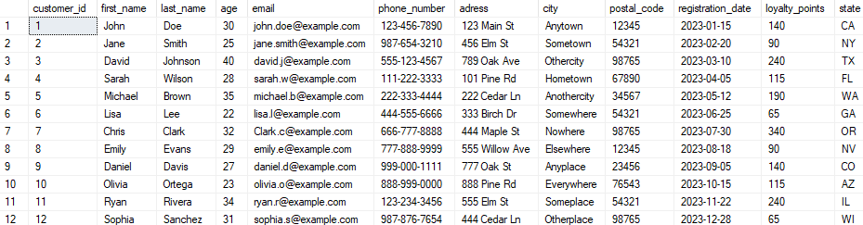
2. --Task 2: Retrieve a list of customers who are older than 25 years old.  
   select * from Customer where age < 25;  
   
3. --Task 3: Update the email address of a specific customer in the table where customer_id =7.  
   select * from Customer where customer_id = 7 update Customer set email ='Clark.c@example.com' where email='chris.c@example.com';  
   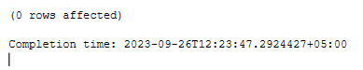
4. --Task 4: Add a new customer to the table.  
   INSERT INTO Customer VALUES(13, 'Ben', 'Stokes', 34, 'ben.stokes@example.com', '123-456-9876', 'Main St 22', 'Everywhere', 'texas', '54321', '2023-09-25', 0);  
   
5. --Task 5: Delete a customer from the table based on their customer_id.  
   delete from Customer where customer_id=13;  
   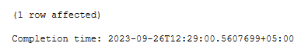
6. --Task 6: Retrieve a list of customers who live in a specific city.  
   select * from Customer where city ='Anytown'  
   
7. --Task 7: Calculate the average age of all customers.  
   select avg(age) from Customer  
   
8. --Task 8: Increase the loyalty points of all customers by a certain amount.  
   update Customer set loyalty_points = loyalty_points+20  
   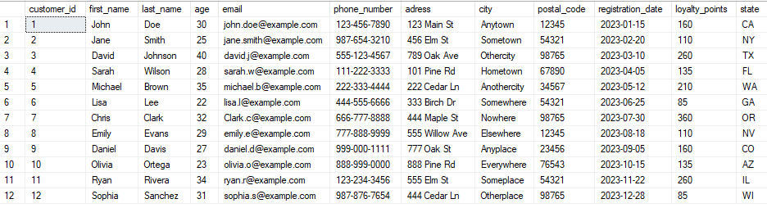
9. --Task 9: Find the customer with the highest loyalty points.   
   select max(loyalty_points)from Customer;  
   
10. --Task 10: Retrieve a list of customers whose loyalty points exceed 100.  
    select * from Customer where loyalty_points>100  
    